NAME:P.THIRUPUGAZHI

ROLL NO:2019PECEC220

REGISTER NO: 211419106279

AUTOMATIC TRASHCAN USING ARDUINO UNO,ULTRASONIC SENSORS AND SERVO MOTOR

COMPONENTS:

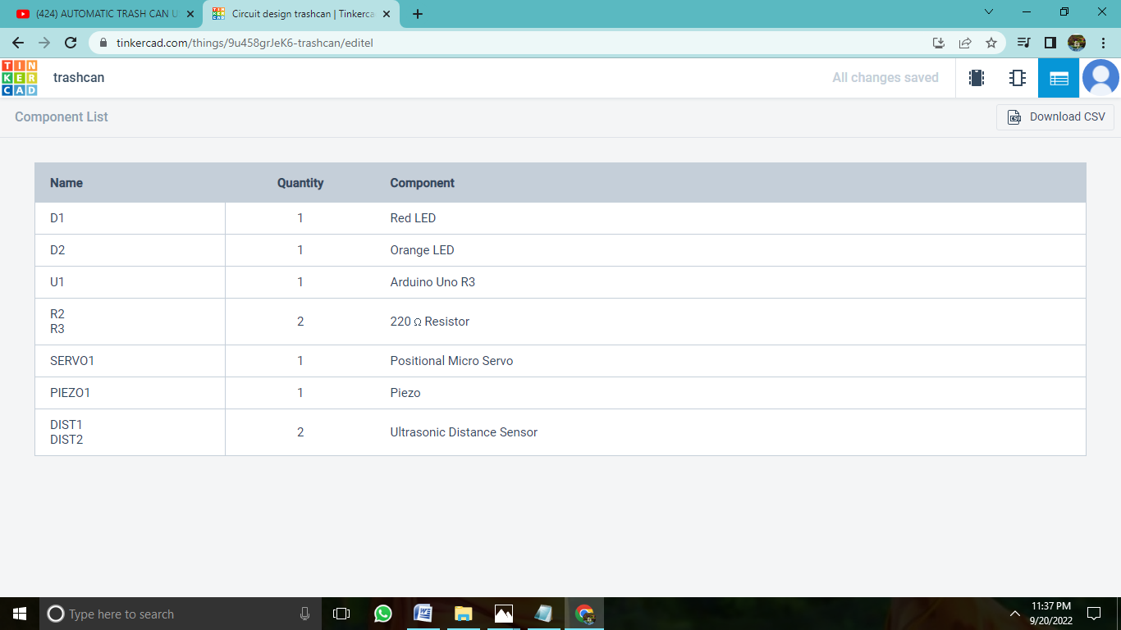

DESIGN

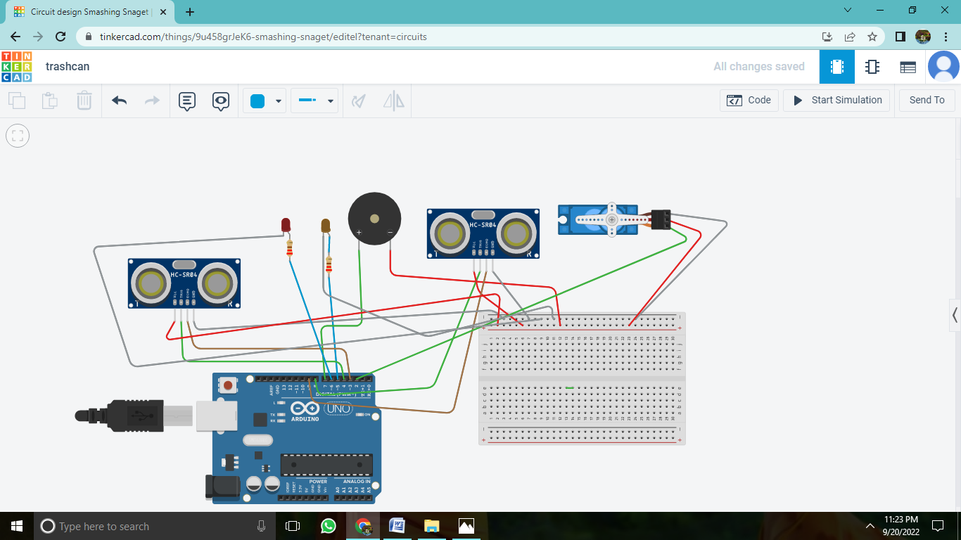

OUTPUT

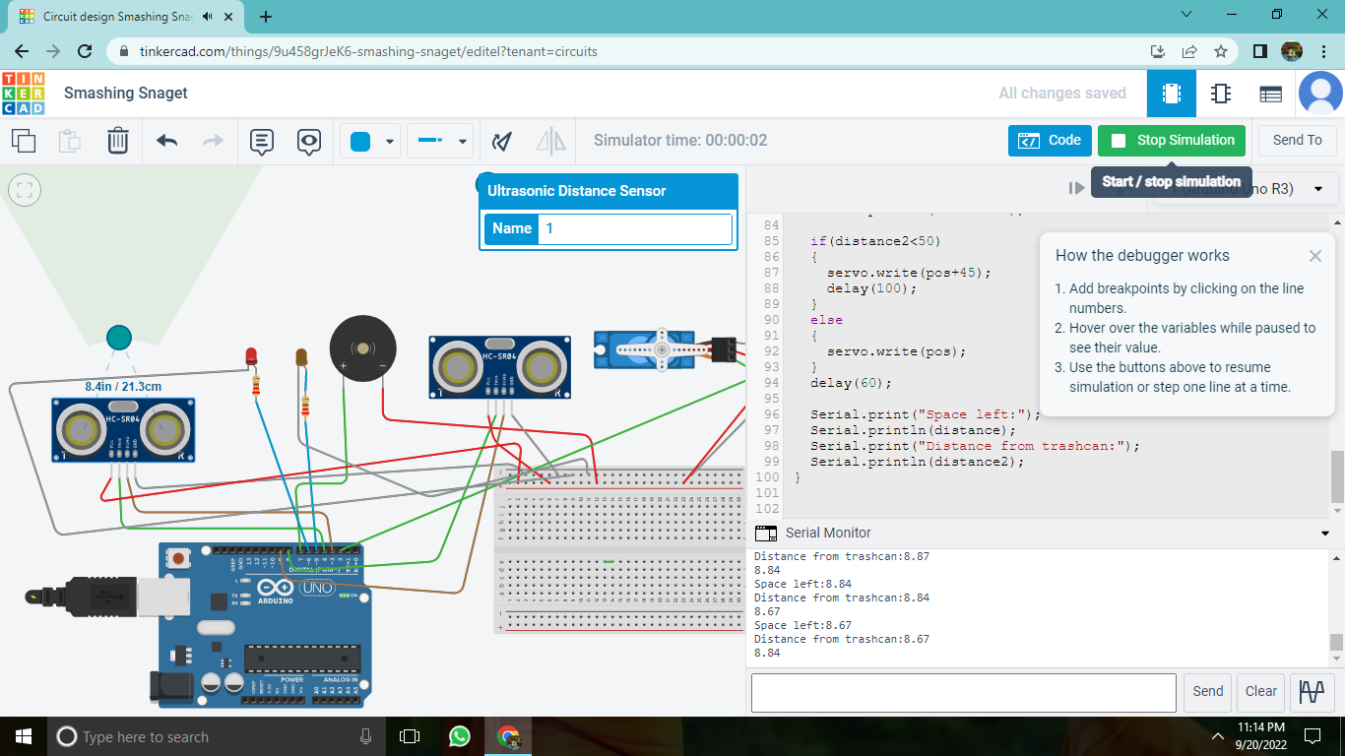

CODE

#include <Servo.h>

Servo servo;

int pos = 0;

const int trigPin = 4;

const int echoPin = 3;

int orange = 5;

int red = 6;

const int trigPin2 = 8;

const int echoPin2 = 9;

int buzzer = 7;

long duration;

long duration2;

float distance;

float distance2;

void setup()

{

pinMode(trigPin, OUTPUT);

pinMode(echoPin, INPUT);

pinMode (orange, OUTPUT);

pinMode(red, OUTPUT);

pinMode(echoPin2, INPUT);

pinMode(trigPin2, OUTPUT);

pinMode (buzzer, INPUT);

servo.write(pos);

servo.attach (2);

}

void loop()

{

Serial.begin(9600);

digitalWrite(trigPin, LOW);

delayMicroseconds(2);

digitalWrite(trigPin, HIGH);

delayMicroseconds (10);

digitalWrite(trigPin, LOW);

duration pulseIn(echoPin, HIGH);

distance 0.034 (duration/2);

digitalWrite(red, LOW);

digitalWrite(orange, LOW);

if (distance < 10) {

digitalWrite(red, HIGH);

digitalWrite(orange, LOW);

}

else if ((distance <= 30) && (distance >= 10))

{

digitalWrite(red, LOW);

digitalWrite(orange, HIGH);

delay (500);

}

digitalWrite(orange, HIGH);

delay(500);

else {

digitalWrite(red, LOW); digitalWrite(orange, LOW);

delay (500);

}

//buzzer

if (distance < 10) {

tone (buzzer, 1000, 500);

else {

pinMode (buzzer, INPUT);

noTone (buzzer);

}

//sensor 2

digitalWrite(trigPin2, LOW);

delayMicroseconds(2); digitalWrite(trigPin2, HIGH);

delayMicroseconds(10);

digitalWrite(trigPin2, LOW);

digitalWrite(buzzer, LOW);

duration2 = pulsein (echoPin2, HIGH);

duration2=0.034\*(duration2/2);

Serial.println(distance2);